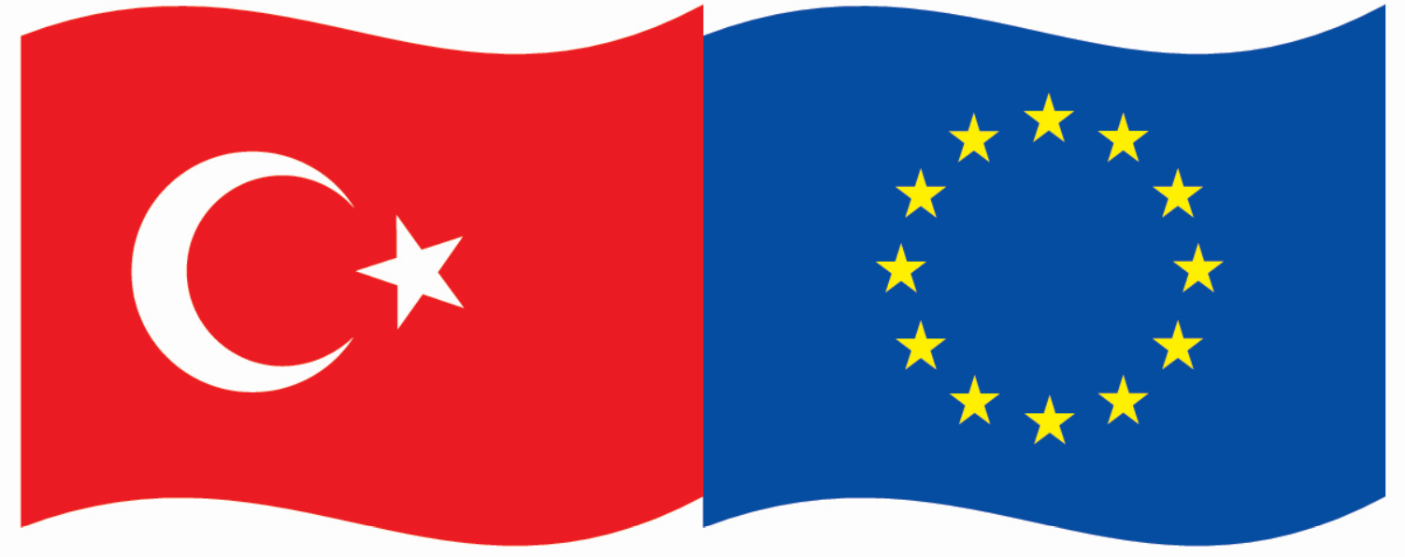

This project is co-funded by the European Union and the Republic of Turkey



**Energy Efficiency Activity**

**APPLICATION FORM**

**APPLICATION FORM**

Turkey-EU Business Dialogue (TEBD) – Energy Efficiency activity 2021

Virtual Activity – May 2021 - July 2021

**Please, fill in the document by typewriter**

Deadline: Monday 12th April 2021 (4:00pm)

|  |  |
| --- | --- |
| **Last Name** |  |
| **First Name** |  |
| **Position** |  |
| **Your Chamber** |  |
| **Address** |  |
| **Email** |  |
| **Direct Office Phone** |  |
| **Mobile Phone** |  |
| **Chamber Twitter Account** |  |
| **Chamber Facebook Account** |  |
| **English Knowledge** | **Yes / No** |

**Questions below will be used as a reference in the selection process.**

**The TEBD team may ask for additional information if required.**

**A. YOUR ORGANISATION**

Please describe briefly the main features of your Chamber: (i) Profile of your Members (ii) Internal structure and (iii) Main activities (max 15 lines).

|  |
| --- |
|  |

**B. YOUR BACKGROUND**

Please explain your personal background (short CV): studies, professional experience in the theme, role in the Chamber (max 10 lines).

|  |
| --- |
|  |

**D. CONSULTANCY KNOWLEDGE**  
Please indicate if you have a concrete knowledge or experience in supporting SMEs in the mentioned field.

**C. YOUR MOTIVATION**

Please explain in detail why you wish to participate in the Energy Efficiency activity and which benefits of your participation will bring to your Chamber in the short and long run (max 15 lines).

|  |
| --- |
|  |

Signed: ______________________________ Date:____________________________

**MORE INFORMATION**

Please contact Ángela Ustárroz [ustarroz@eurochambres.eu](mailto:ustarroz@eurochambres.eu)

Tel +32 2 282 08 79